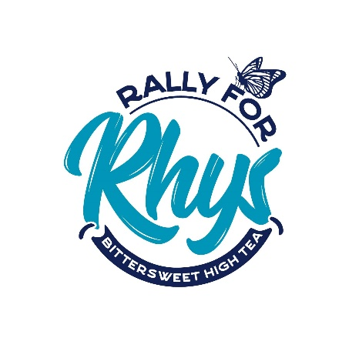
FREQUENTLY ASKED QUESTIONS
What does my ticket include?
A buffet style high tea in the beautiful ballroom at Country Club Tasmania, unlimited sparkling, guest speakers, live acoustic entertainment, lucky door prizes, ‘Makers Shop’ with arts, crafts and delicious things (ideal for gifts for Mother’s Day on Sunday 13th) live auction, raffle draw and a relaxed afternoon with friends!
Is my ticket refundable?
No, but if you are unable to attend for any reason, please email rallyforrhys@outlook.com. We can post on the Rally For Rhys Facebook page on your behalf to attempt to sell your ticket. We cannot guarantee this will result in the sale of your ticket. It will be your responsibility to manage the transaction.
Is there seat allocation?
This is a seated event with 3 x 100 seat tables. There will not be seat allocation. You will be ushered to your seat by one of our wonderful Committee members.
Do we all have to arrive together?
It is helpful when we are seating guests in the ballroom that you all arrive together. It is recommended if you are waiting for friends to wait in the foyer at the bottom of the ballroom stairs and proceed up to the ballroom once you are all together. If you are coming in a group of 8 or more we suggest you arrive on time/early to ensure adequate seating together.
Will there be EFTPOS available?
There will but 2 terminals however we recommend bringing some cash to save lining up. There are redi-ATMs in the main foyer and water garden of Country Club Tasmania.
Will there be door sales?
No. All tickets must be pre-purchased at https://launcestontickets.com.au/event/rally-for-rhys-bittersweet-high-tea-6517. If you need assistance purchasing your tickets, please email rallyforrhys@outlook.com.
What if I have special dietary requirements?
When purchasing tickets do let us know at this point if you or your guests have any special dietary requirements. All food items will be Gluten, Dairy and Nut free.
What is the dress code?
There is no dress code however many of our guests use the day as a nice excuse to ‘frock up’ and enjoy a day out with the girls.

Where can I park?
http://www.countryclubtasmania.com.au/en/parking.html
Are there other ways to get to Country Club Tasmania?
http://www.countryclubtasmania.com.au/en/transport.html
What time is the Makers Shop open?
The makers shop will be open from 1pm until 4.30pm sharp. All purchases must be collected prior to 4.30pm.
Can prizes or purchases be delivered?
Unfortunately, prizes cannot be delivered due to the volunteers time commitment, we appreciate your understanding.
Can I arrange collection later?
Certain items can be arranged to be collected within one week of the event. Email rallyforrhys@outlook.com This will be subject to the discretion of the Makers Shop Supervisor ie. baked items will need to be taken at the end of the event.
What is Bittersweeet?
Bittersweet is a private Facebook page which allows Bereaved Parents, Siblings and Grandparents a platform to share, grieve and support each other. Offering hope to those so broken to persist with the overwhelming journey of loss. If you are a bereaved parent, sibling or grandparent and would like more information please email bittersweet@netspace.net.au.
How much of proceeds will go to the project?
There is a small cost in the administration of such an event such as ticketing fees or signage however the Committees and workers of both Rally for Rhys and Bittersweet are all unpaid volunteers. This means the vast majority of the proceeds will be used to fund the building of a memorial.
How can I receive information about the Rally for Rhys project?
By liking our Facebook page https://www.facebook.com/Rally-for-Rhys-Bittersweet-High-Tea-786186724899592/
Can I donate items to be sold in the makers market or auction?
Any support is greatly appreciated and we kindly accept donations by emailing Shannon at rallyforrhys@outlook.com.
How can I volunteer?
One of the greatest things you can do is spread the word, attend the event and bring all your friends. If you would like to offer to work in a role on the day please email rallyforrhys@outlook.com. Any help is appreciated!

